《Object-Oriented Systems Analysis and Design》
Project Report
Project Name | Alarm
Teammates | 迪马
My Name | 德米特

- Project description：

When the program starts, the user will be shown a window with three buttons. With their help, the user will be able to: set an alarm that is triggered once; alarm that will be triggered periodically; and remove previously set alarms.

- Design Patterns: (including class diagrams, relative codes, screen shots and proper explanation)

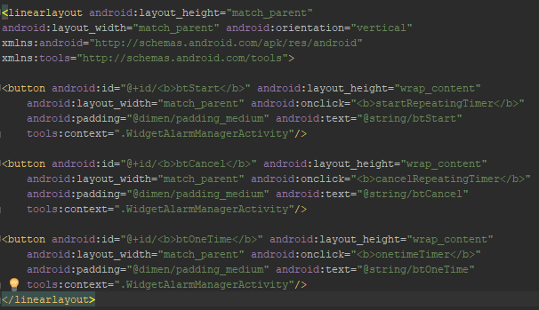
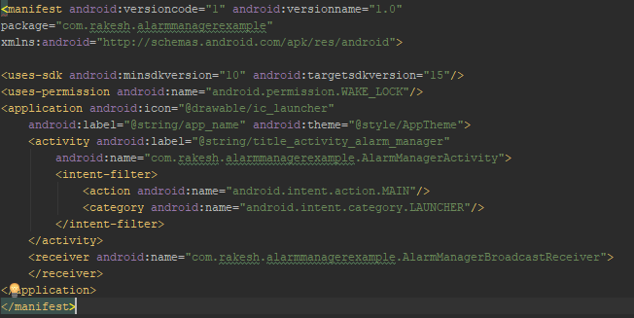

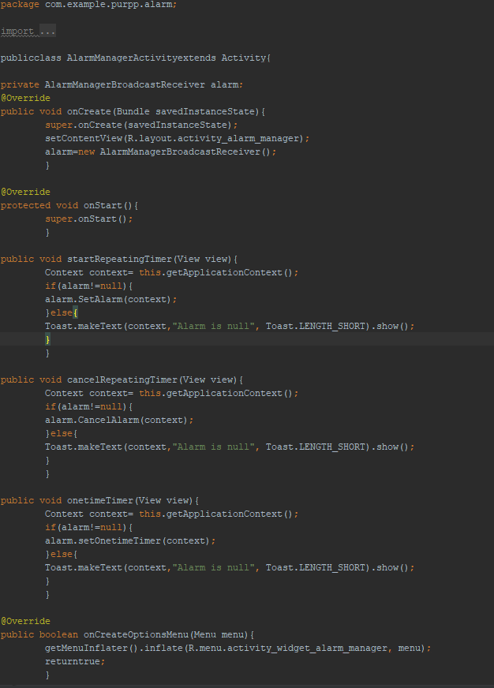
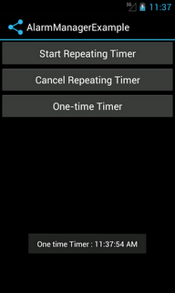

- Perspectives about object-oriented design patterns:

In this application, you can quickly and easily set the alarm at any time and it will always help you Wake up at the set time. This application has a very user-friendly design, where it is impossible to get confused and even without explanation you will understand everything.

